Tax Year Lookup
Often you will want to apply something to an entire Tax Year. The field shown below may be used to help you quickly find a Tax Year, and is available throughout the Tax Administration application:


- Tax Year: If you know the Tax Year you are seeking, you may simply enter it and move on in the window that you are working in.

- Find: If you do not know the Tax Year you are seeking, click on “Find” and the Lookup window will appear. Refer below for further instructions on use of the Lookup window.

The Lookup Window

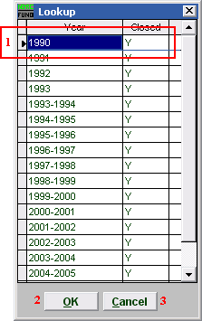
- You may use the arrow keys on your keyboard to move the highlighter to the Year you are seeking, or you may click on the year you are seeking. If the year is closed, then a “Y” will appear in the “Closed” column.

- OK: Click “OK” when you’ve highlighted the year you are seeking. This will return you to the window you were working in.

- Cancel: Click “Cancel” to return to the window you were working in without choosing a Tax Year.

